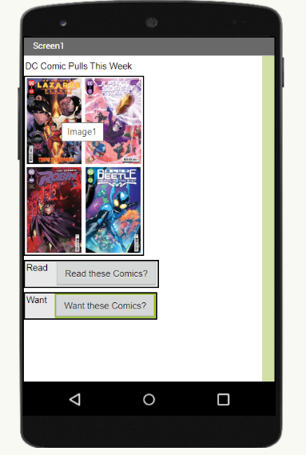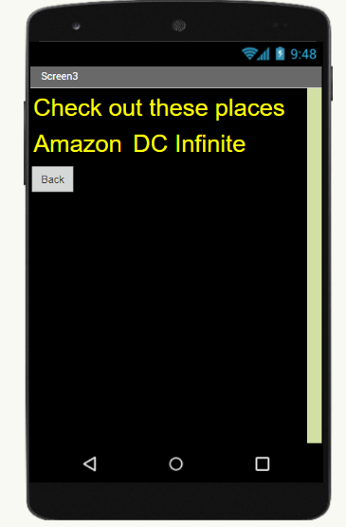

What does your app do?

When you click the read button, it takes you to a screen where it gives a congrats message. If you click the want it takes you to a screen to say where you can find them on.

How did your design change from what you imagined in your mind?

My design was originally had a much more complex design and was more of a cataloguing app, but this turned into more of useless app because I didn’t have the skill level to accomplish the goal.

What did you enjoy about the process? What did you find challenging?

I enjoyed creating something and then seeing it do what you wanted it too. It was challenging to be able to get everything where I wanted it and I had a vision and it didn’t turn out the way I wanted it.

Test Cases

League of Comic Geeks <https://apps.apple.com/us/app/comic-geeks/id874775221>

The basic purpose of this app is to be able to record the comic books that you read. That way you can keep track of what you have read and what still needs to be read. Clicking on a comic book will show information about the comic book.

1. Use of the search bar
   1. Enter the phrase Batman and comic books with Batman in the name should show up.
2. Image Links
   1. Click on the image of a comic book and the link should take you to a new page with info about that comic.
3. Barcode Scanner
   1. Open the barcode scanner on the search page and the camera should scan a barcode of a comic.
4. New Comics
   1. Go to Release page and click new comics, different comic brands should be shown
5. Comic Brands
   1. Clicking DC Comics should show you DC Comic books.
6. Read Comics
   1. Click the read button and the button should turn yellow.